Multiple-choice section – choose the correct answer

Question 1 [1.4]

Calculate: 2 + (-5) × (-3) – (-4)

A 24 B 18 C 21 D -9

Question 2 [1.5]

Simplify: 

A 3 × 4 × 5 B 32 × 42 C 32 × 42 × 5 D 3 × 42

Question 3 [2.1]

Write $2\frac{7}{20}$ as a decimal.

A 2.35 B 2.7 C 2.20 D 2.72

Question 4 [2.6]

Convert % to a fraction in simplest form.

A $\frac{1}{6}$ B $\frac{1}{8}$ C  D $\frac{12.5}{100}$

Question 5 [3.2]

If *x* = 2 and *y* = -5, then $\frac{x-2y}{4}$ is equal to:

A 2 B -4 C 3 D -6

Question 6 [3.4]

4*x*2 + 8*x* – 7*x*3 – 4*x*2 – 3*x* simplified is:

A 5*x* – 7*x*3 B 8*x*2 – 4*x*3 + 5*x* C 5*x*2 – 4*x*3 + 8*x* D 7*x*3 + 5*x*

Question 7 [4.2]

Write the ratio 50 g : 4 kg in simplest form.

A 50 : 4 B 50 : 4000 C 1 : 8 D 1 : 80

Question 8 [4.6]

45 jellybeans shared in the ratio 1 : 4 is:

A 15 : 30 B 45 : 4000 C 9 : 36 D 5 : 40

Question 9 [5.4]

Which of the following unit conversions is incorrect?

A 3.5 m2 = 35 000 cm2 B 1.5 km2 = 1 500 000 m2

C 27 000 m2 = 27 ha D 55 000 mm2 = 550 cm2

Question 10 [6.2]

The coordinates of a point that lies on the graph of *y* = -2*x* + 3 are:

A (0, -3) B (-3, 9) C (1, 5) D (-3, -9)

Question 11 [8.1]

In the diagram, a pair of alternate angles is:

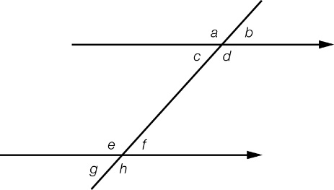

A *c* and *f* B *c* and *e* C *c* and *b* D *a* and *c*

Question 12 [9.7]

This Venn diagram shows the number of elements in each of the two sets *A* and *B*.

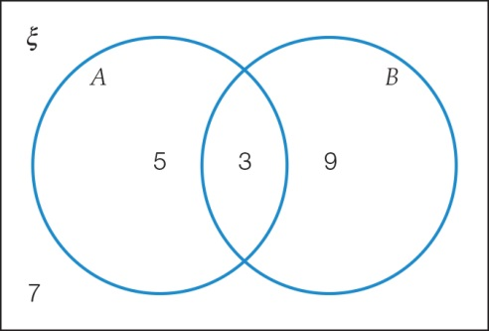

*n*(not *B*) is:

A 7 B 5 C 12 D 15

Multiple-choice results: \_\_\_ /12

Short answer section

Question 13 11 marks

Choose the correct word from the following list to fill each of the gaps in the following sentences.

*expression Cartesian plane index surd equation coefficient origin   
non-terminating decimal constant quadrilateral expanded pronumeral*

(a) The expression 24 is in \_\_\_\_\_\_\_\_\_\_\_\_\_\_\_\_\_ form, while 2 × 2 × 2 × 2 is written in \_\_\_\_\_\_\_\_\_\_\_\_\_ form.

(b) An irrational number is a \_\_\_\_\_\_\_\_\_\_\_\_\_\_\_\_\_\_\_\_\_\_\_\_\_\_\_\_\_\_\_\_ that cannot be written as a fraction and when written in the form of a square root is called a \_\_\_\_\_\_\_\_\_\_\_\_\_\_\_\_.

(c) In the \_\_\_\_\_\_\_\_\_\_\_\_\_\_\_\_\_ 2*a* + 4, the number 2 is the \_\_\_\_\_\_\_\_\_\_\_\_\_\_\_\_\_\_ and the letter *a* is called the \_\_\_\_\_\_\_\_\_\_\_\_\_\_\_\_\_. The number 4 all by itself is the \_\_\_\_\_\_\_\_\_\_\_\_\_\_\_\_\_\_\_.

(d) A parallelogram is a \_\_\_\_\_\_\_\_\_\_\_\_\_\_\_\_\_\_\_\_\_\_\_\_\_ with two sets of parallel sides.

(e) The \_\_\_\_\_\_\_\_\_\_\_\_\_\_\_ is the point at which the *x*- and *y*-axes intersect on the \_\_\_\_\_\_\_\_\_\_\_\_\_\_\_\_\_.

Question 14 2 marks [8.2]

Explain how a square can be classified as a rectangle, but a rectangle cannot be classified as   
a square.

Question 15 6 marks [1.4]

Evaluate the following.

(a) 6 × (-7) – 56 ÷ (-8) (b) 8 ÷ (-2) + 2 × (6 + 3 × 9 ) – 11

Question 16 5 marks [1.6]

Evaluate the following.

(a)  (b) (-4)2 × (-2)3

Question 17 2 marks [2.1]

Arrange the following list into descending order by converting fraction values to decimals first.

2.03, $\frac{3}{10}$, 3.32, $\frac{1}{5}$, 2.003

Question 18 5 marks [2.3]

Calculate the following, writing your answer in simplest form.

(a) -5.2 × -4.5 (b) $\left(3\frac{5}{8}- 2.25\right)÷-1\frac{2}{3}$

Question 19 3 marks [2.6]

Layla is conducting a science experiment. She takes a beaker and fills it with a chemical solution so that it is  full. She then adds 12 mL of water so that the beaker is 50% full. Find the maximum number of millilitres that the beaker can hold.

Question 20 2 marks [3.2]

If *x* = -2, *y* = 4 and *z* = 8, what is the value of $z\sqrt{x^{4}y}$?

Question 21 2 marks [3.4, 3.5]

Simplify the following by collecting like terms or cancelling first.

(a) 3*x*2 + 6*xy* – 5*x –* 8*yx* + 4*x*2 – 3*x* (b) 

Question 22 3 marks [3.5]

Given that the area of the following rectangle is 40 cm2, determine the value of *x*.

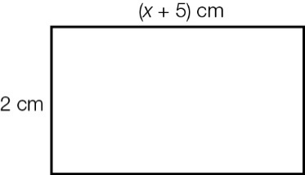

Question 23 2 marks [4.2]

Simplify the following ratios, taking into account the associated units.

(a) $3\frac{2}{3} :4$ (b) 2 days : 2 weeks : 1 fortnight

Question 24 2 marks [4.4]

If 2*b* = *a* and 3*c* = *b* then what is the ratio of *a*:*b*:*c* equivalent to?

Question 25 2 marks [4.6]

A concrete mixture contains cement, sand and gravel in the ratio 2 : 4 : 5. How much concrete can be made if you have a 50 kg bag of cement? (Keep to the above ratio.)

Question 26 2 marks [5.1]

A present is wrapped with a ribbon as shown. What length of ribbon should be used if 60 cm must be left over to tie a bow?

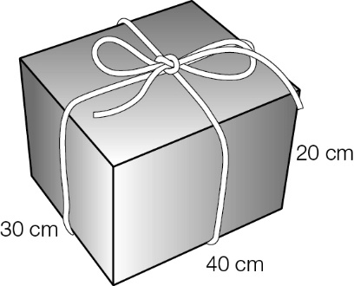

Question 27 3 marks [5.6]

Calculate the area of the following shape, correct to 2 decimal places.

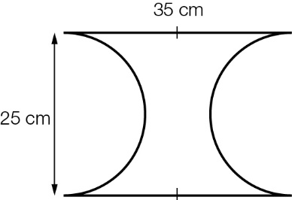

Question 28 3 marks [5.7]

A water cooler used at a football game has a radius of 30 cm and a height of 90 cm. The water cooler is used to fill individual water bottles that have a capacity of 1.25 litres each. How many water bottles can be completely filled from one full water cooler?

Question 29 4 marks [7.3]

Find the value of the pronumeral in each of the following equations.

(a) 3(2*a* + 7) = 3 (b)  = 13

Question 30 5 marks [7.4]

Find the value of the pronumeral in each of the following equations.

(a) 5*a* + 3 = 11 + 3*a* (b)  = 

$\frac{3(b+2)}{4}=\frac{(2b-3)}{2}$

Question 31 6 marks [8.1]

Find the value of the pronumerals in each diagram. Give reasons for your answers.

|  |  |
| --- | --- |
| (a)  PM8_SmB_YearT_06 | (b)  PM8_SmB_YearT_07_RR |

Question 32 5 marks [8.2]

Find the value of the pronumerals in each diagram. Give reasons for your answers.

|  |  |
| --- | --- |
| (a)  PM8_SmB_YearT_08_RR | (b)  PM8_SmB_YearT_09_RR |

Question 33 2 marks [8.4]

Show that the following pair of triangles are congruent, stating the congruence test used.

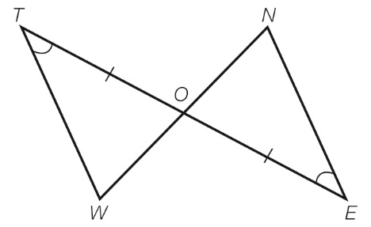

Question 34 2 marks [9.2]

Over the first nine games of a basketball season, Carla scored an average (mean) of 24 points per game. In her tenth game she scores 54 points. Find her average after ten games.

Question 35 2 marks [9.6]

A netball player scores a goal six times out of every 10 shots for goal. What is the probability of her shooting two goals from the next two throws?

Short answer results: \_\_\_ / 81

Extended answer section

Question 36 5 marks [2.10]

Joel plans to spend $1000 on a refrigerator. He can get a staff discount of 10% from his workplace. He can also get a discount of 30% during a sale. He wonders which discount he should ask for first.

(a) How much will it cost if the 10% discount is taken off first, then the discount of 30% taken off what is left?

(b) How much will it cost if done the other way?

(c) Which is the better option?

Question 37 3 marks [9.2]

Ricky scores the following eight scores during a cricket season:

2, 20, 24, 24, 24, 42, 52, 60

Ricky argues that the 2 should be removed because it was a trial game. Out of mean, median and mode, which will change if the 2 is removed? Provide a brief explanation of why the other measures of central tendency do not change.

Question 38 4 marks [9.6]

A particular dartboard is made from a 3 × 3 grid of identical squares, as shown below. To play the game, you use two darts and you win if your total score is 30 or more. Darts that completely miss the dartboard are returned and thrown again until a score is recorded.

What is the probability of winning at this game? The probability of a dart hitting each square is the same. Note: you can hit the same square with both darts.

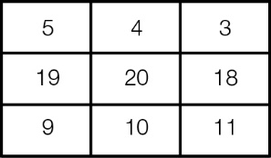

Extended answer results: \_\_\_ / 12

TOTAL test results: \_\_\_ / 105